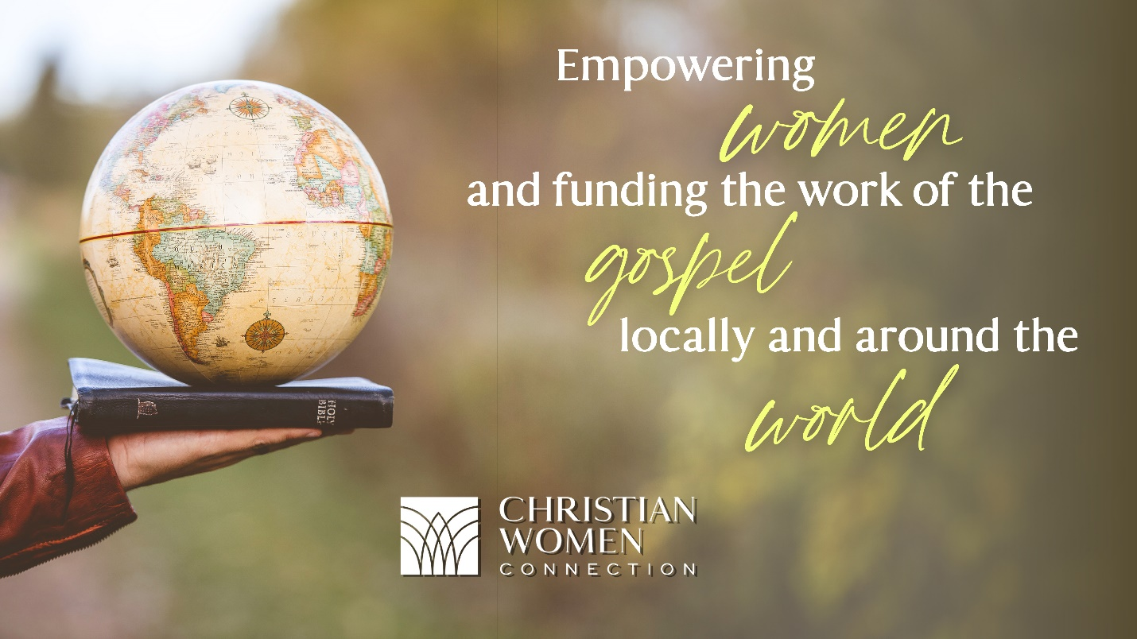



Discover a global network of women ready to live out their calling.

Become a Member

As a Christian Women Connection Member, you are grafted into the blessing of leadership training, spiritual growth, and fellowship

You do not have to be a member of the Church of God to join or participate in.

The local chapter meet on the second Thursday of each month at 10:00 am

If you are interested in joining and/or visiting our group and have any question, please call Susan at 386-546-0143.

**Mission**

When you improve the lives of women, you change the world.

We exist to build relationships with women **everywhere**. We provide ministry resources to the Church of God and to other groups to connect women through **relationships**, **spiritual formation**, and **service**.  
  
We support others as they train and empower women for leadership in peace building and reconciliation.

https://christianwomenconnection.org/connection/